*Case Study 6.2:* ***Biking day with high carb lunch***  Bernie V.2 04 Oct 2023

I set for most of the day a **70% profile**, and had only a minimal breakfast in order to keep iob low when starting to bike.

Additionally I activated the exercise mode, using a **TT=125 mg/dl** which I kept running over lunch time, but for a shorter period than the 70% profile.

In just seconds I was able to „frame“ the upcoming exceptional situation for my loop, to manage me fully automatically through the day!

Of course, in my initial set-up and tuning, I had to first „learn“ from my looping data, where about %profile and set TT should lie for the kind of exercise that I was up to. But, no need to make a science out of it. Unless you are competing in professional sports, it should be good enough to go by gut feeling, and by experience („what setting should I slightly alter the next time?“).

Using the top button row on the AAPS main screen, I just input the 70% and 125, which goes super fast and easy. It will immediately turn

* from all three fields grey,
* to „70%..“ on the profile field-turned-yellow, „125 .. „ in the TT field-turned-yellow, and also the exercise field lit yellow in the middle.

So, very easy to see on one glance, I am in the exercise mode, and which are the key settings (see picture with „95“ glucose below).

And in case I want to prematurely exit, or adjust a parameter, same easy procedure, just within 1-2 seconds, right from my AAPS home screen.

A **70% profile** was set for the entire day until dinner (AAPS screenshot) This modulates my 0.55 U profile basal to 0.7 * 0,55 = 0.39 U (see p.6, emulator line 20)

**Exercise mode** with a **125 mg/dl TT** was set in meant another basal reduction of 33%%, to 67% of 0,39U= 0,26 U (p.6, emulator line 19).

The exercise mode also results in a **dynamic_iobTH** which goes, like basal, also 33% lower:

* from my default settings in /Preferences = 60% * 11 (maxIOB) = 6.6 U iobTH w/o exercise…
* …to 0.67* 6.6 = 4.4 U iobTH* on exercise day.

These measures lead to a pretty overall glucose curve for this biking day, which included a fairly substantial lunch (duck, french fries, a fancy salad with fruit in it), as well a piece of cake at the end of the tour:

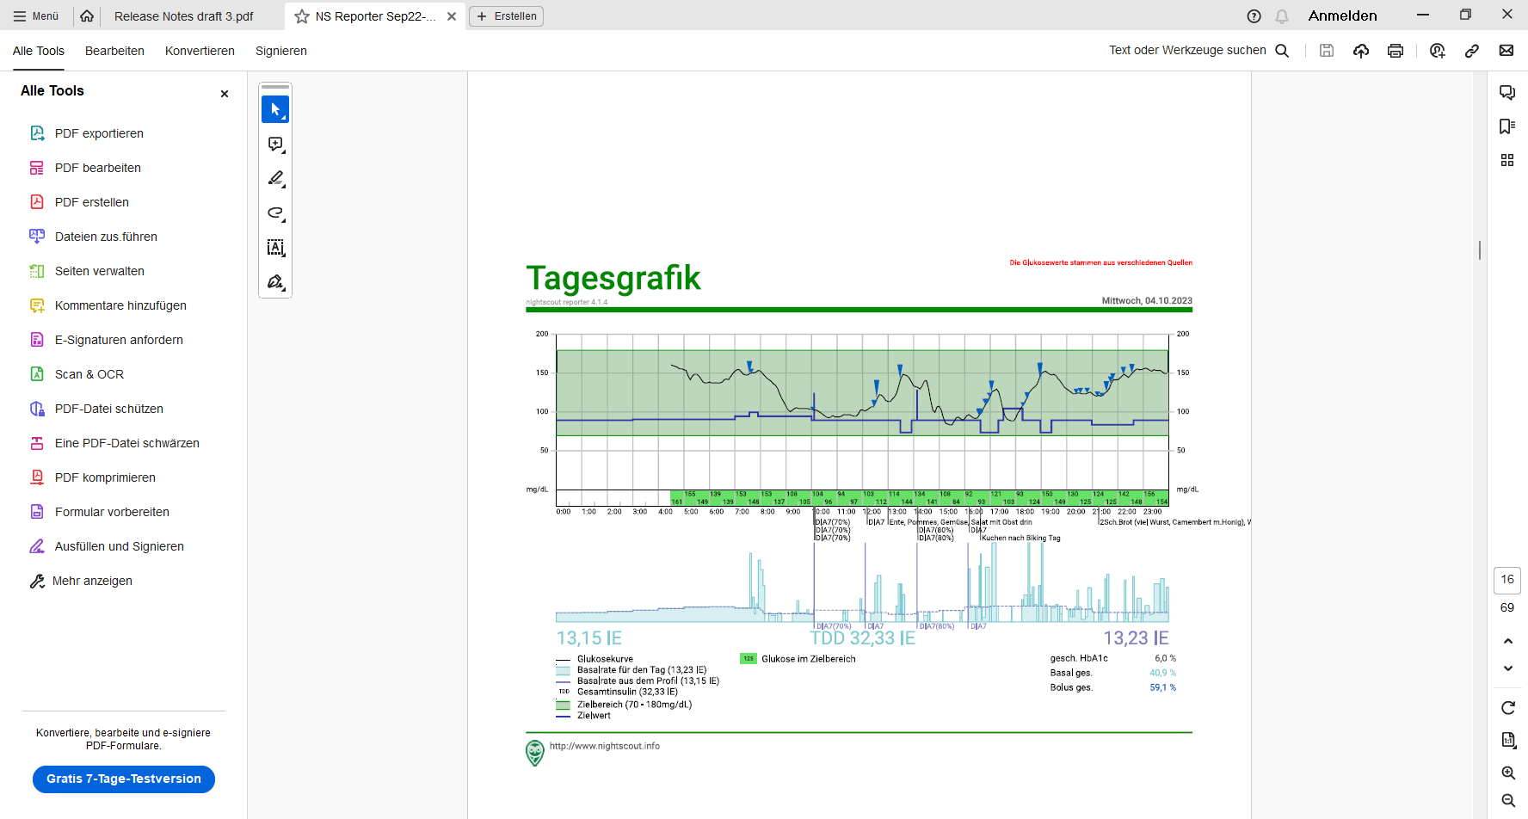

(No carbs entered, no bolus given). The lunch iob hump in middle of the bottom graph of the chart below shows that the 4.4 U iobTH was preventing higher iob as would be normal for a big lunch.

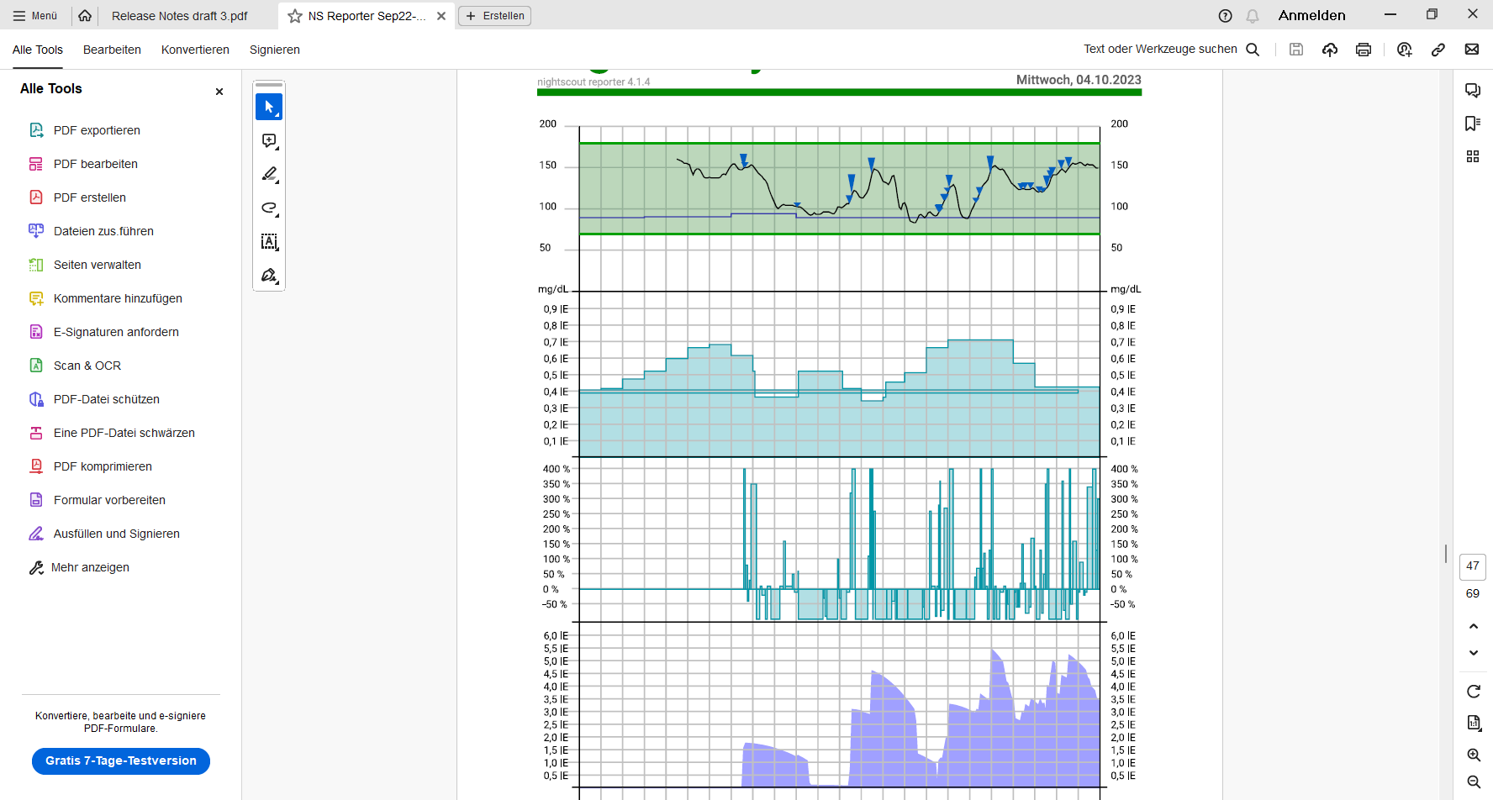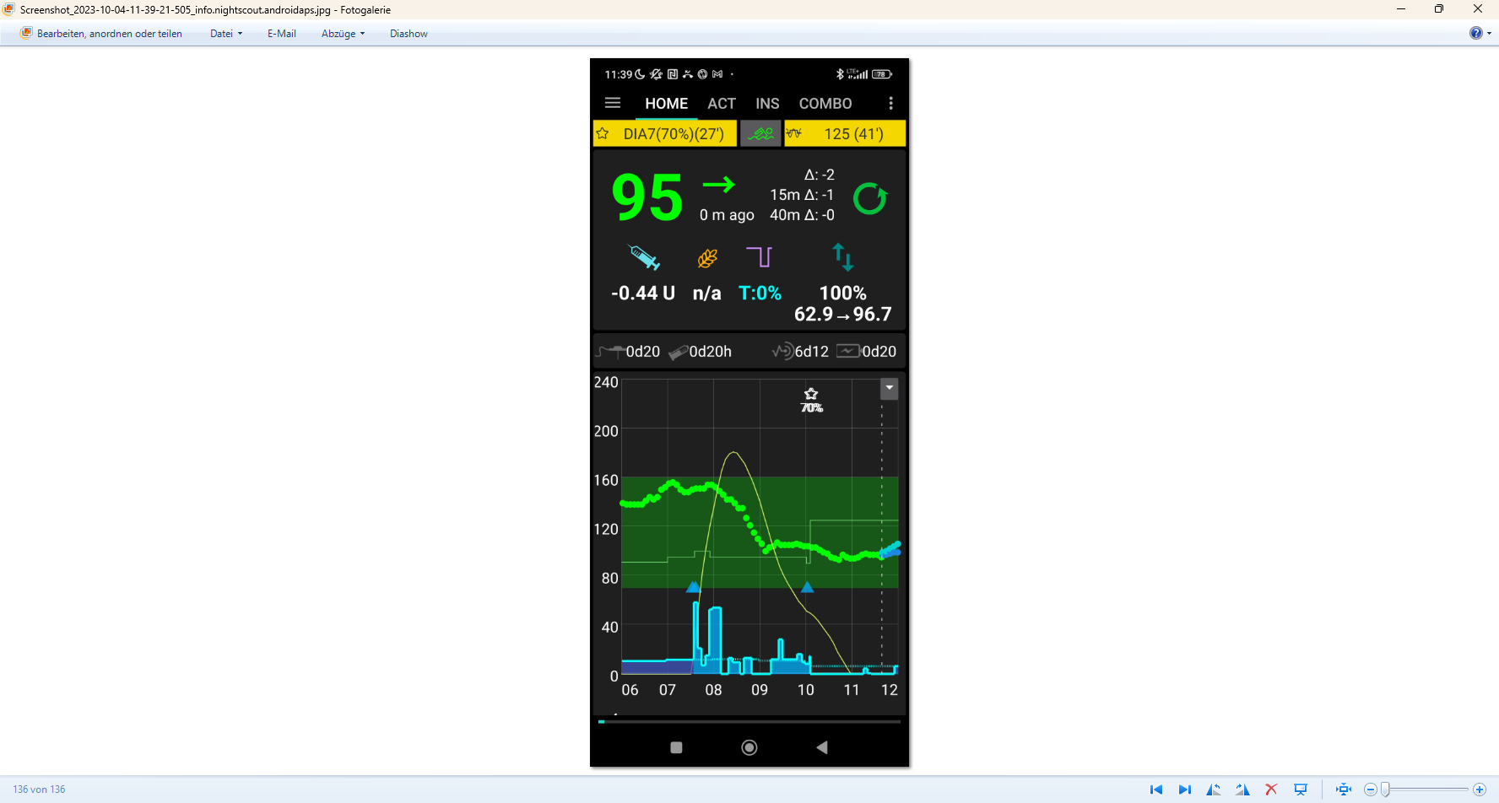

< **4.4 U**

Conclusions from this example:

The example demonstrated that using the **exercise mode with a selected sports TT** will soften the loop response.

profile Target

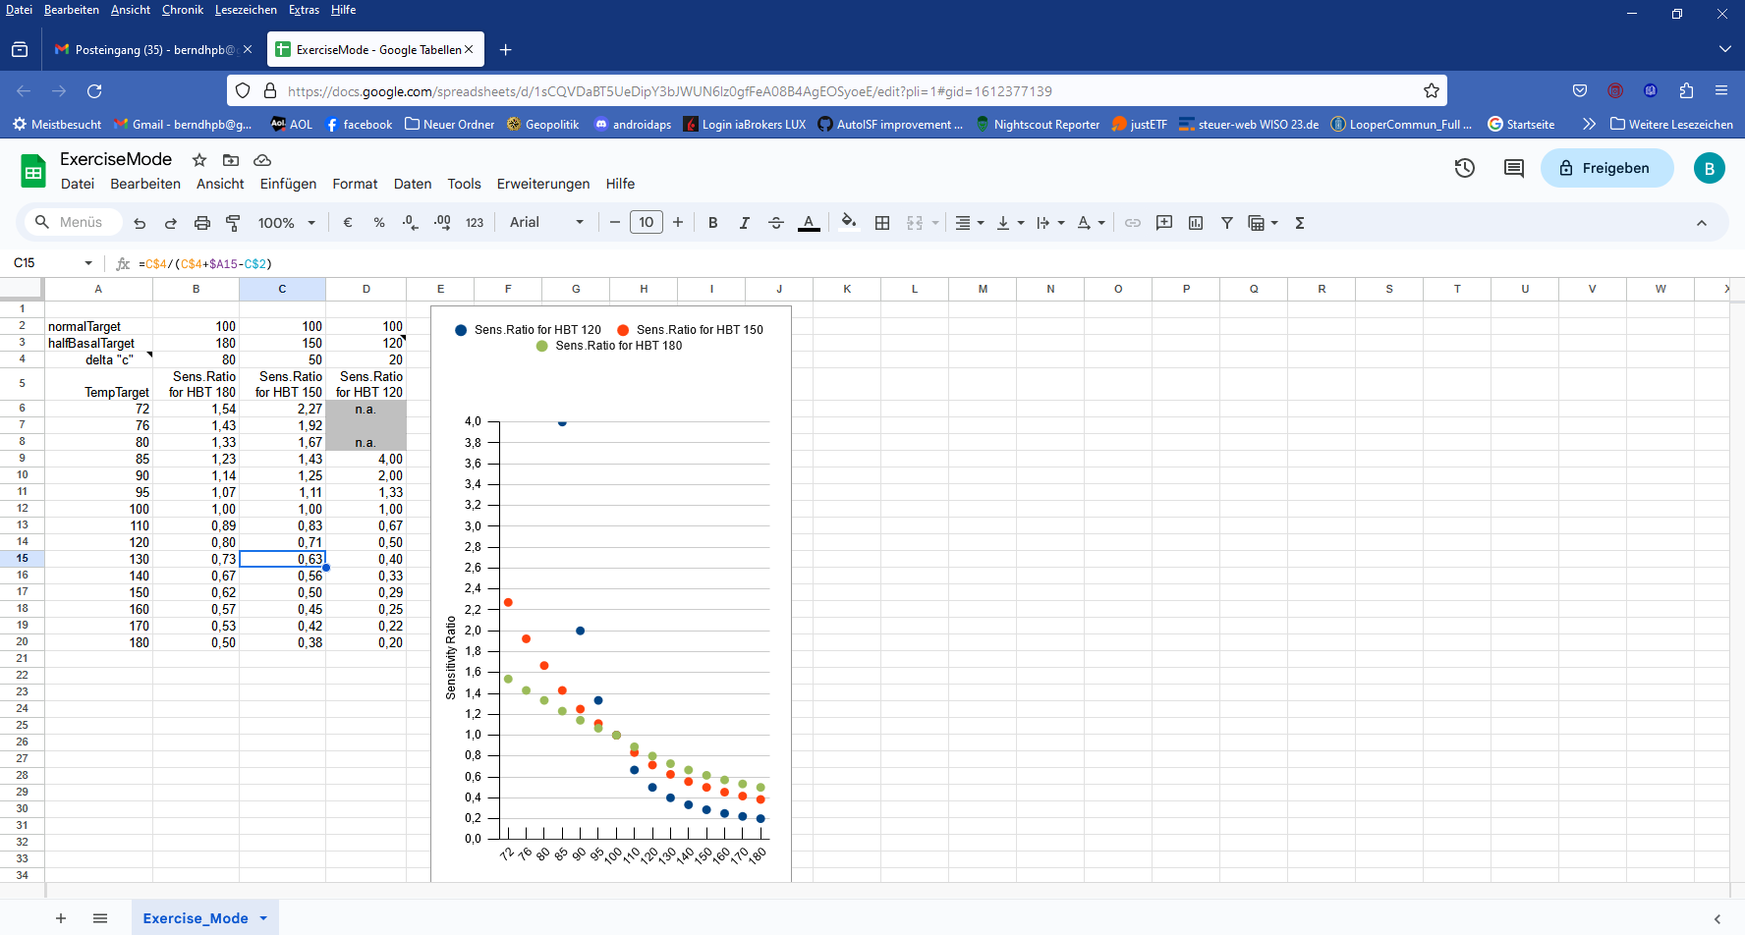

Background, how sensitivity ratio is automatically reduced (-> lower basal, higher ISF), and how dynamic_iobTH works in the exercise mode (-> lower iobTH, to reduce iob for meals on exercise days) see sections 3.3 and 6.4. The delta (how much higher the set exercise target is above profile target), and the half-basal-exercise target set in AAPS/preferences during your initial set-up define the sensitivity ratio the loop uses.

Table: Your general set half-basal exercise target set in Preferences (its distance to the valid profile target), and what TT you set in your exercise mode, lets you differentiate the desired loop aggressivenes.

Note that the **reduced temp.% profile** (on top of using the exercise mode with an elevated TT)multiplies with the results in above table, and further reduces basal *but not* iobTH. Dynamic_iobTH is strictly tied to the exercise mode and TT set.

*If the suggested „cockpit“ user interface would already be in place*, I could have gone through the day with just one time un-critical step (as discussed in section 6.5.2 ). Should during my exercise arise a need to stop a selected mode, or to change a setting, I could do this withinn 1-2 seconds also right from the AAPS home screen („FCL cockpit“).

For their kinds of favourite exercise, users must, over time, learn what combination of settings (half-basal_exercise_target,TT, %profile) leads to good-enough results.

As the loop re-calculates every 5 minutes, it is *not* important to get things *exactly* right. Adjustments (every 5 minutes) allow the loop to still keep things under good-enough control.

The time windows for doing the profile switch, and for setting a suitable TT can differ (and they can also be automated, so not to require multiple inputs over the course of your exercise day). Using all available tools allows a nearly surgical approach to what you want to achieve for your favourite type(s) of exercise.

Logfile analysis with the emulator

Skip this last section, unless you like to learn more about using the emulator.

Analysis of my biking day with the emulator required to load the logfiles from my phone into the PC, and to have the files for the emulator downloaded from Github.

1. Load an empty vdf file, and access to logfiles (erasing the end with UTZ time, and putting an asterics after date_ => all of that date get loaded into the mask
2. Define the time window of interest, using UTZ (= MEZ summertime minus 2) in the last two lines (right hand side input fields) of the form:

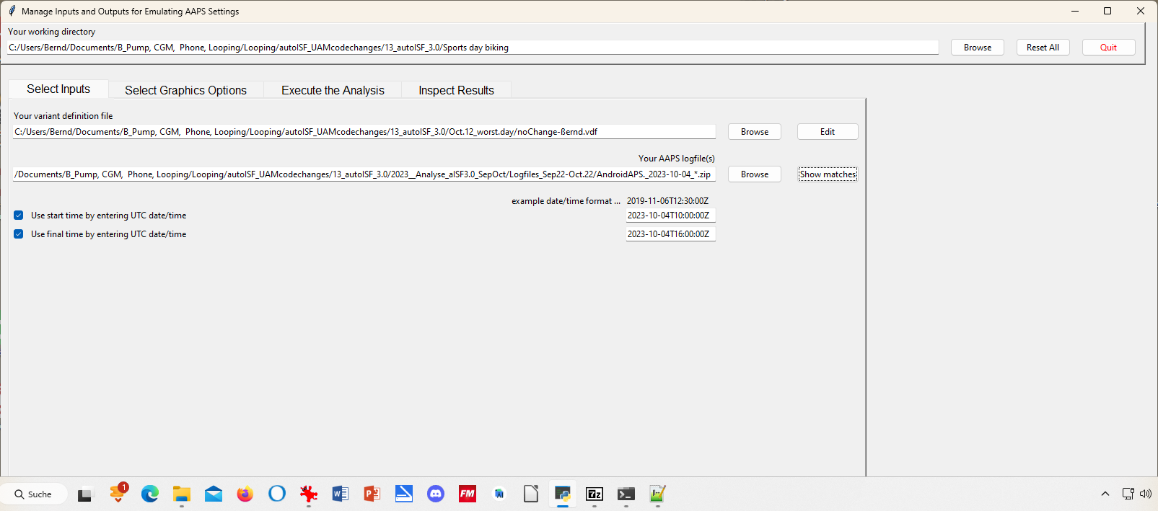

1. Execute Analysis / Run Emulation yields results as table:

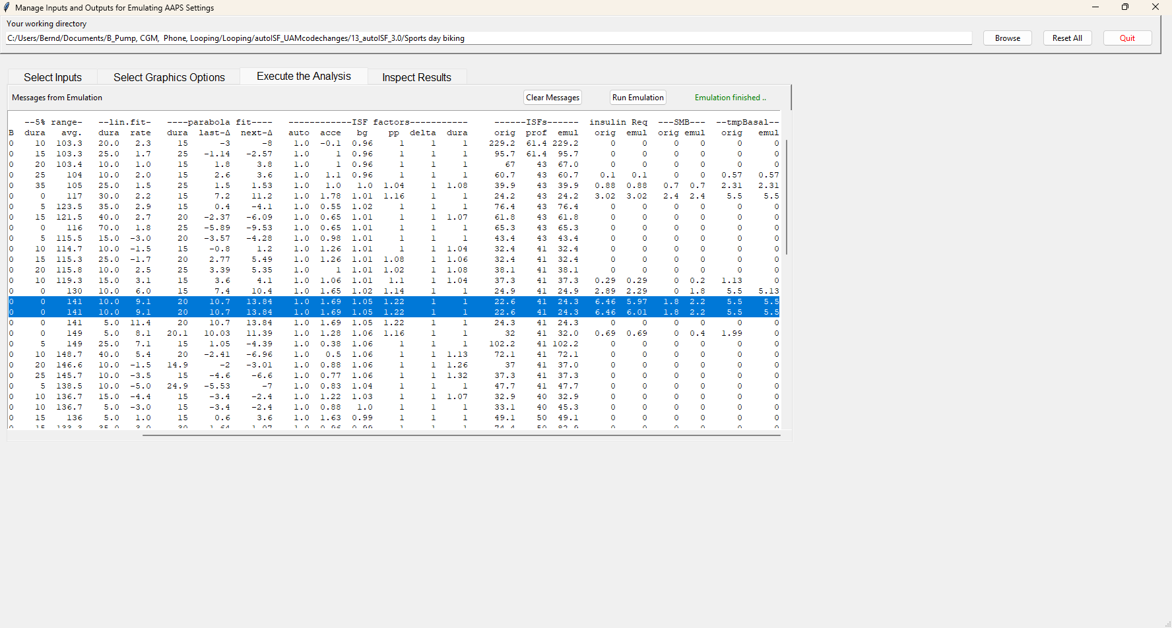

In line 6 (12:34 CET) a 2.4 U big SMB is given, driven by bgAcel_ISF factor of 1.78

Highlighted is 13:29 CET (for some reason there is duplicated line for it). Here, a big insulinReq of 6,5 U is cut down to a SMB of only 1.8 U..

1. … to see how our settings, TT and and sports button worked here, and what iobTH applied, we must look into the logs available from: ((alternatively, the SMB tab from exactly those 5 minutes would show, too))

Instead of Execute Analysis, press Inspect results…



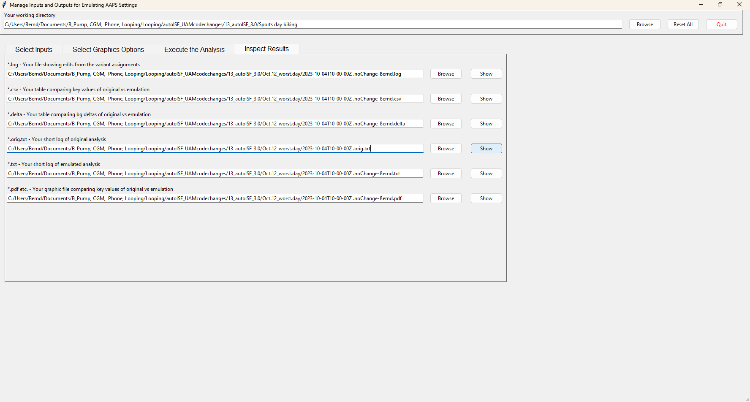

If you press the 4th option you get the logs which include basically all SMB tab info in an exhaustively long list.

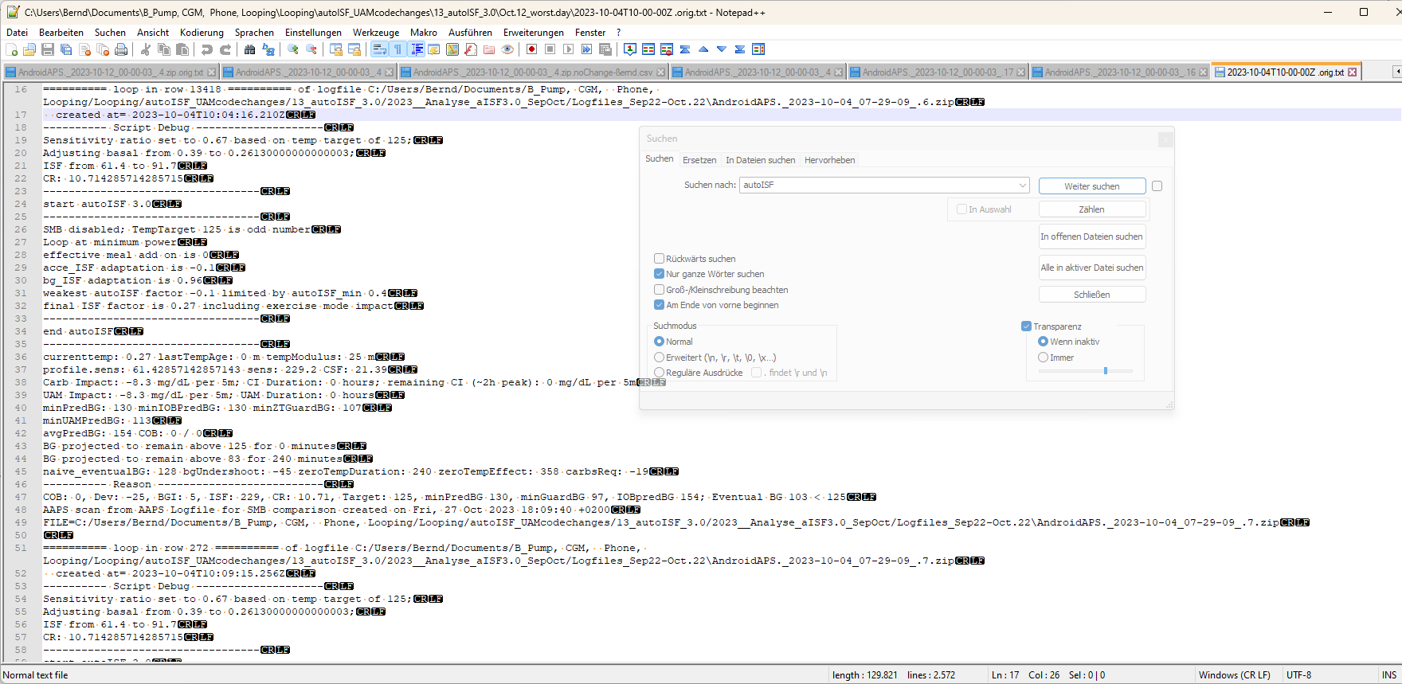

The blue highlighted line shows we are at 10:04 UTZ (12:04 CET) . We can see how sensitivity ratio and also basal were lowered due to sports setting with a 125 mg/dl TT, or 129 used a bit later, which also disabled SMBs.

By using the search function you can jump, in that long list, to all places that e.g. have „autoISF“ in it, or „script debug“, or „SMB disabled“ (if you want to analyze when that happened…)

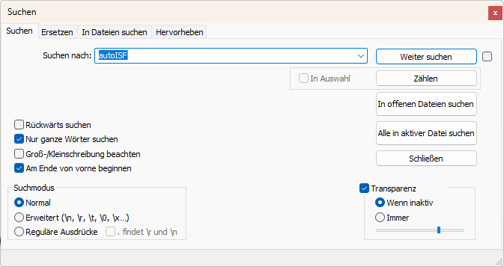

1. Now lets look at 11:29 UTZ (13:29 CET) which was when the first relevant size SMB was issued:

In the following, I copy and shorten texts from the log table as above, for some time points of high interest:

11:29 UTZ (13:29 CET), when SMB was delivered:

loop in row 14007 …..created at= 2023-10-04T11:29:11.005Z

---------- Script Debug --------------------

Sensitivity ratio set to 1.1 based on temp target of 74;

Adjusting basal from 0.55 to 0.6050000000000001;

ISF from 41 to 37.3

CR: 7.5

So, we see the meal TT of 74 (set by one of my Automations for cases in which I did not bother to set an EatingSoonTT) temp. overrides the exercise target and sharpens the applicable ISF: ((It also elevates basal ; note that TBRs can run several 100% of basal))

----------------------------------

start autoISF 3.0

----------------------------------

SMB enabled; TempTarget 74 is even number

Loop at full power

effective meal add on is 0.04

acce_ISF adaptation is 1.81

bg_ISF adaptation is 1.05

pp_ISF adaptation is 1.22

dura_ISF by-passed; bg is only 0m at level 141

final ISF factor is 1.81

----------------------------------

end autoISF

----------------------------------

profile.sens: 41 sens: 22.6 CSF: 3.01

minPredBG: 220 minIOBPredBG: 135 minZTGuardBG: 94 minUAMPredBG: 231

avgPredBG: 220 COB: 0 / 0

BG projected to remain above 74 for 240 minutes

IOB 2.033

Full loop capped SMB at 1.87 to not exceed 130 % of effective iobTH 30%

… maxBolus: 3.2

---------- Reason --------------------------

Eventual BG 304 >= 74, insulinReq 6.46. Microbolusing 1.8U. adj. req. rate: 13.53 to maxSafeBasal: 5.5, temp 2.75 < 5.5U/hr.

1. A look at the cake after 14:20 (16:20 CET):™

From 14:09 UTZ (16:09 CET) on, I discontinued the 129 sports TT and the loop reverted to 90 mg/dl profile target.

This made SMBs possible after starting to eat cake (then).

However, 14:14 - .19 - .24 and :29 there was no insulinRequired yet (while ISF factor gradually ramped up from 0.52 to 1,09 (line 1735, 1772, 1807) .

At 14:34 UTZ (16:34 CET) a first cake related SMB of 0.5 U was issued based on 0,66 U ins.Requ (line 1897), and based on a bgAccel_ISF factor of 1,54 (and final ISF factor of 1,52).

As there is a **>10 mg/d delta** (glucose rise), **my Automation** kicks in and sets for the next loop decisions (for 26 minutes is as my Automation defines it) a **TT=74** mg/dl which makes the loop more aggressive from 14:37 on:

created at= 2023-10-04T14:37:15.371Z

---------- Script Debug --------------------

Sensitivity ratio set to 1.1 based on temp target of 74;

Adjusting basal from 0.48 to 0.528;

ISF from 39 to 35.5

CR: 6.6

----------------------------------

start autoISF 3.0

----------------------------------

SMB enabled; TempTarget 74 is even number

Loop at full power

acce_ISF adaptation is 1.64

bg_ISF adaptation is 1

pp_ISF adaptation is 1.08

dura_ISF adaptation is 1.11 because ISF 35.5 did not do it for 30 m

final ISF factor is 1.64

----------------------------------

end autoISF

----------------------------------

profile.sens: 39 sens: 23.8

avgPredBG: 94 , BG projected to remain above 74 for 240 minutes

IOB 0.438 Eventual BG 100 >= 74, insulinReq 0.84. Microbolusing 0.6U.

created at= 2023-10-04T14:39:16.537Z

---------- Script Debug --------------------

Sensitivity ratio set to 1.1 based on temp target of 74;

Adjusting basal from 0.48 to 0.528;

ISF from 39 to 35.5

CR: 6.6

----------------------------------

start autoISF 3.0

----------------------------------

SMB enabled; TempTarget 74 is even number

Loop at full power

effective meal add on is 0.04

acce_ISF adaptation is 1.25

bg_ISF adaptation is 1

pp_ISF adaptation is 1.06

dura_ISF by-passed; bg is only 5m at level 97.5

final ISF factor is 1.25

----------------------------------

end autoISF

----------------------------------

profile.sens: 39 sens: 31.2

avgPredBG: 78 BG projected to remain above 74 for 240 minutes

IOB 1.114

Eventual BG 84 >= 74, insulinReq 0.13; setting 30m low temp of 0.04U/h. Microbolusing 0.1U.